THE INFLUENCE OF EMOTIONS ON MEMORY, ATTENTION,
AND DECISION MAKING

Explicit memories are stored memories that are retrieved by active conscious thought and include:

episodic memory – a collection of memories for personally
experienced events (your wedding) and

semantic memory – memory of general world knowledge that is
accumulated over a lifetime (math skills).

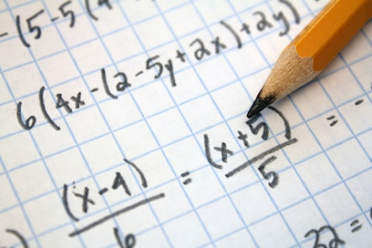
(Junebug Weddings, n.d.)
(Magoosh Online Test Prep, n.d.)

Implicit memories are stored memories that are retrieved without conscious awareness that include:

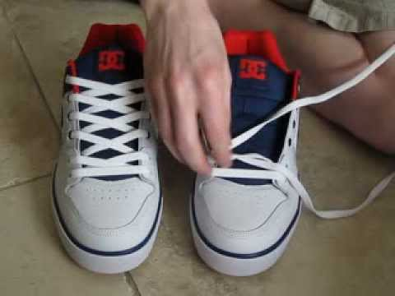
procedural memory – memories of well-practiced skills (tying your shoes),

priming – something that triggers a subsequent memory (image of Thanksgiving dinner),

(Stuntmotomoto, n.d.)
(Better Homes and Gardens, n. d.)

classical conditioning – a conditioned response to a sound (warning siren), and

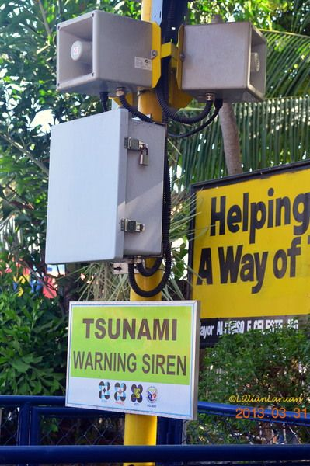
(Redgage, n.d.)

non-associative learning – involves unnoticed sounds (wind chimes).
(Walmart, n.d.)

How Culture and Social Influences Affect Emotional Control

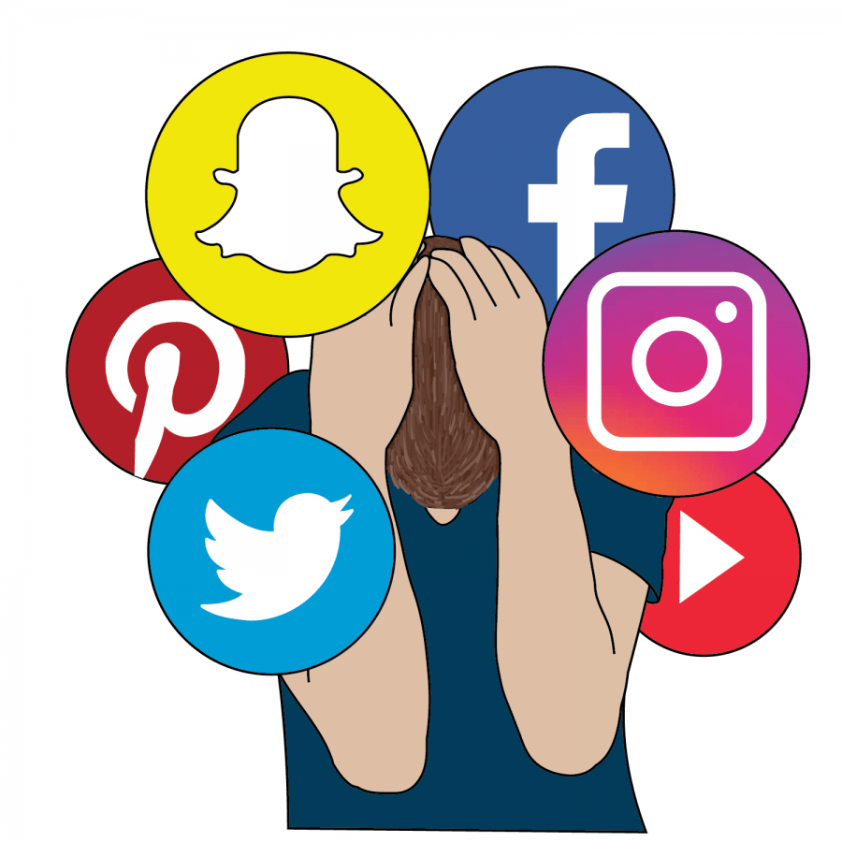

Ju et al. (2022) conducted a survey that explored the moderating role of negative emotions, such as anxiety and fear, during the COVID-19 pandemic crisis. Findings suggested interpersonal health information seeking across social media platforms for health protective measures linked social media use and influenced behaviors to the degree individuals perceived behaviors as expected norms (Ju et al., 2022).

(London Meets Paris, n.d.)

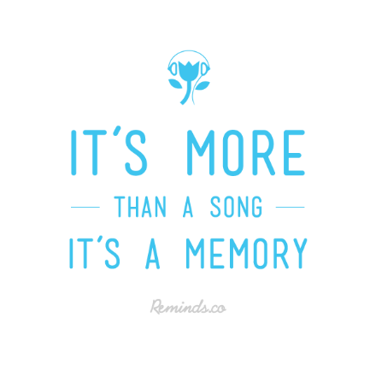
How Culture and Social Influences Affect Reactions to Memory

Weston (2021) reported on how The Peoples History of Pop musical series foregrounded memory objects, their materiality, and related affects as an approach to the representation and re-presentation of history and memory. He revealed that a complex aesthetic and sentimental strategy was built upon the ability of images to reshape narratives of cultural past that encompassed but blurred boundaries between public and private memory in the recuperation and renegotiation when fans were given opportunity to rewrite the narrative of music history in their own words (Weston, 2021). (Reminds, n.d.)

How Culture and Social Influences Affect Attention

Lang (2019) reported that consumer culture distorts attention by bombarding viewers with ads to simultaneously distract them and capture their attention. The tactic keeps viewers on social media sites, addicted to video games, and glued to shopping sites with a reward of dopamine rushes that render viewers captivated and unable to look away (Lang, 2019). Schindler and Straube (2020) connected emotion and task relevance to attention in a later study and detected different but parallel onsets of emotion and task-relevance effects. Their findings suggested that emotion and task relevance acted independently at the early processing stage but conferred additional processing advantages during later processing with possibility of interaction being restricted when attention was directed toward and emotional category (Schindler & Straube, 2020).
(Industry Research Reports, n.d.)

How Culture and Social Influences Affect Decision Making

Lawrence et al. (2021) conducted research on implicit and explicit memory effects of sexualized and non-sexualized ads embedding in programs viewed by women to determine whether the advertisers achieved their aim of increased brand awareness and sales. Results indicated sexualized advertising led to significantly worse implicit memory for the brand logo but better explicit recall for the advertisement scene itself without any effect of sexual appeals on explicit brand name recall, and no significant effect on advertisement recall of the program type which suggested that it is not a wise decision to include this imagery for female viewers (Lawrence et al., 2021). Modernizing the affect grid would improve its effectiveness by creating a unified framework to examine the role of emotion in decision making (FeldmanHall & Heffner, 2022).
(Jones, n.d.)
References
Better homes and gardens (n.d.). 7 vintage recipes you must serve for a Thanksgiving throwback.
[Pinterest Board]. Pinterest. Retrieved 22 February 2023 from
https://www.pinterest.com/pin/86694361568661571/
FeldmanHall, O., & Heffner, J. (2022). A generalizable framework for assessing the role of
emotion during choice. American Psychologist, 77(9), 1017–1029. https://doi.org/10.1037/amp0001108
Industry Research Reports (n.d.). Global television advertising market impelled by high efficiency [Pinterest Board]. Pinterest. Retrieved 23 February 2023 from
https://www.pinterest.com/pin/631137335266512112/
Jones, T. (n.d.). Stop sexualizing ads [Pinterest Board]. Pinterest. Retrieved 23 February 2023
from https://www.pinterest.com/pin/246079567131250346/
Ju, I., Rho, E., & Hinsley, A. (2022). Poly social media use: Roles of informational norms and
emotion regulation. Journal of Health Communication, 27(11–12), 812–824. https://doi.org/10.1080/10810730.2022.2164387
Junebug Weddings (n.d.). Glamorous outdoor wedding featuring bright colors and a floral
Explosion [Pinterest Board]. Pinterest. Retrieved 22 February 2023 from
Lang Hearlson, C. (2019). The “educated” consumer: The formation of memory, attention,
and imagination in consumer culture. Religious Education, 114(5), 581–593.
https://doi.org/10.1080/00344087.2019.1595911
Lawrence, H., Furnham, A., & McClelland, A. (2021). Sex does not sell: Effects of sexual
advertising parameters on women viewers’ implicit and explicit recall of ads and brands. Perceptual & Motor Skills, 128(2), 692–713.
https://doi.org/10.1177/0031512521990352
London Meets Paris (n.d.). The curse of social media: how social media causes depression
and anxiety [Pinterest Board]. Pinterest. Retrieved 23 February 2023 from
https://www.pinterest.com/pin/714313190911155942/
Magoosh Online Test Prep (n.d.). How to study for the Praxis math [Pinterest Board].
Pinterest. Retrieved 22 February 2023 from https://www.pinterest.com/pin/4785143337688977/
Redgage (n.d.). Upload. [Pinterest Board]. Pinterest. Retrieved 22 February 2023 from
https://www.pinterest.com/pin/537406168007729682/
Reminds (n.d.). #Reminds #memories #memory #quotes #music #songs reminds.co [Pinterest
Board]. Pinterest. Retrieved 23 February 2023 from https://www.pinterest.com/pin/48061921000901904/
Schindler, S., & Straube, T. (2020). Selective visual attention to emotional pictures: Interactions
of task-relevance and emotion are restricted to the late positive potential.
Psychophysiology, 57(9), e13585. https://doi.org/10.1111/psyp.13585
Stuntmotomoto (n.d.). How to lace shoes the normal way and with no bow [Pinterest
Board]. Pinterest. Retrieved 22 February 2023 from
https://www.pinterest.com/pin/86694361568661571/
Walmart (n.d.). Pure garden metal and wood wind chimes for soothing outdoor décor (silver).
[Pinterest Board]. Pinterest. Retrieved 22 February 2023 from
https://www.pinterest.com/pin/112027110570534283/
Weston, L. (2021). (Re)writing music history: Television, memory, and nostalgia in
the people’s history of pop. Velvet Light Trap, 88, 59. https://doi.org/10.7560/VLT8806

